See Zhi Qian
J22037941/ 105277702
Section: C2

Data Visualization
Use this link for Hosting: https://jeffreyszq.github.io/COS30045/COS30045
Use this link for GitHub https://github.com/JeffreySZQ/COS30045
Lab Exercise Demonstration 4 (Exercises 7.1-8.2) (Week 9)
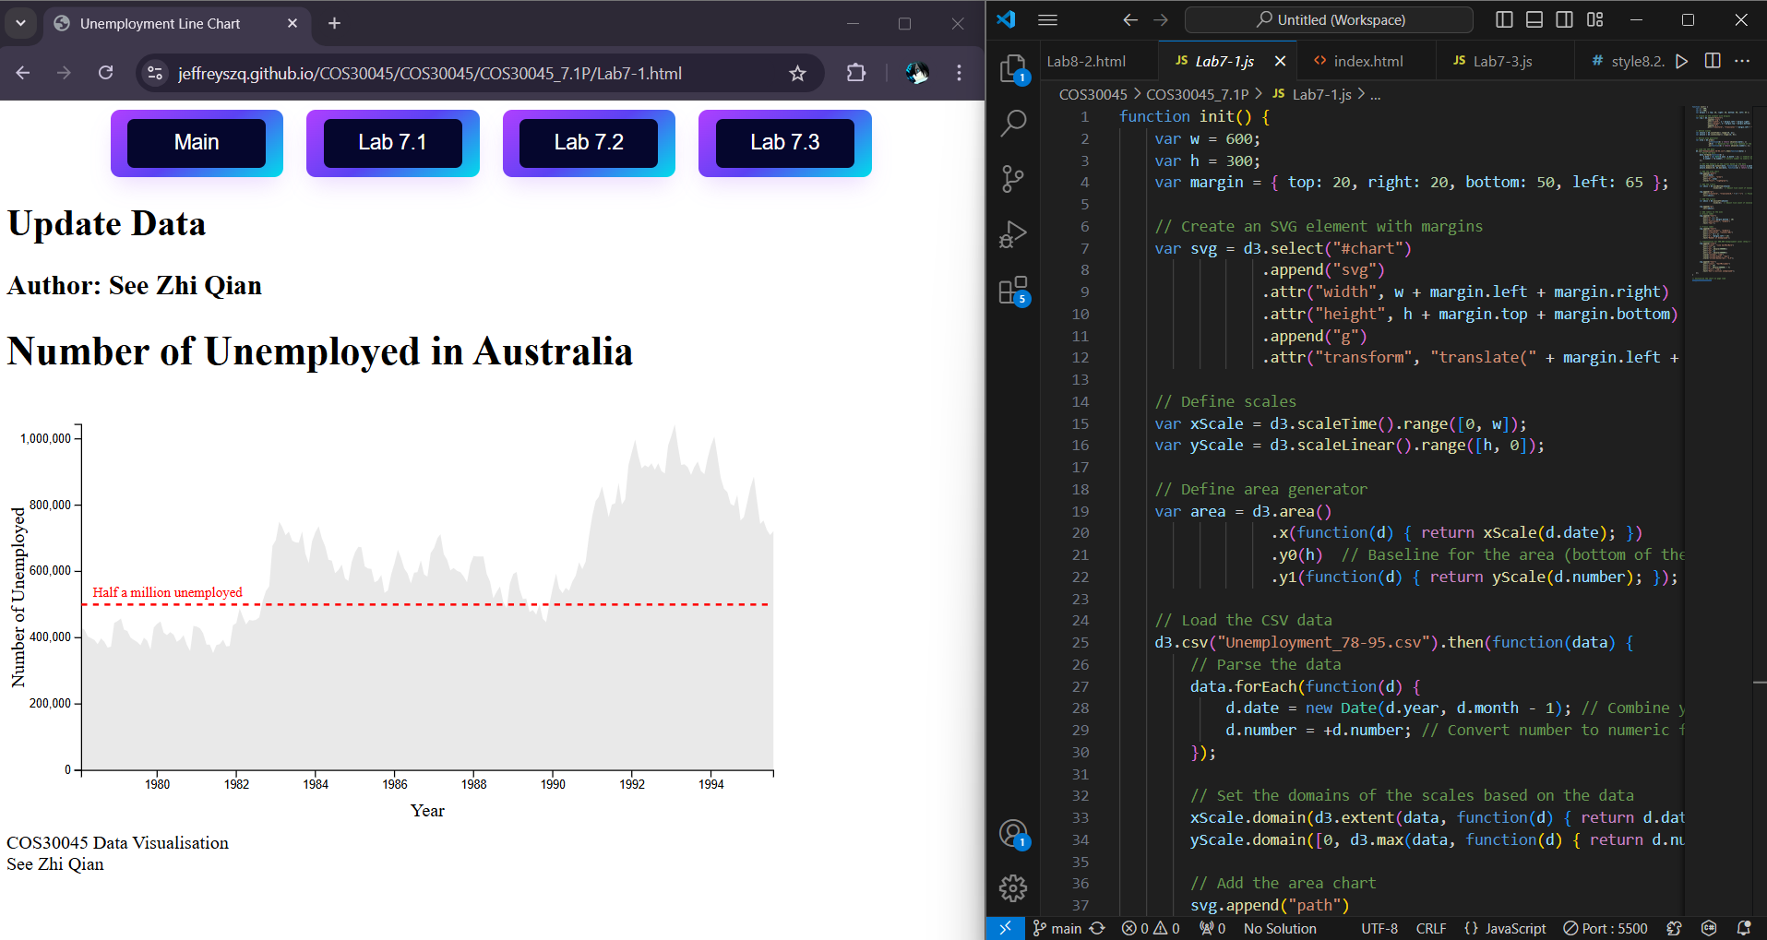
Lab7.1

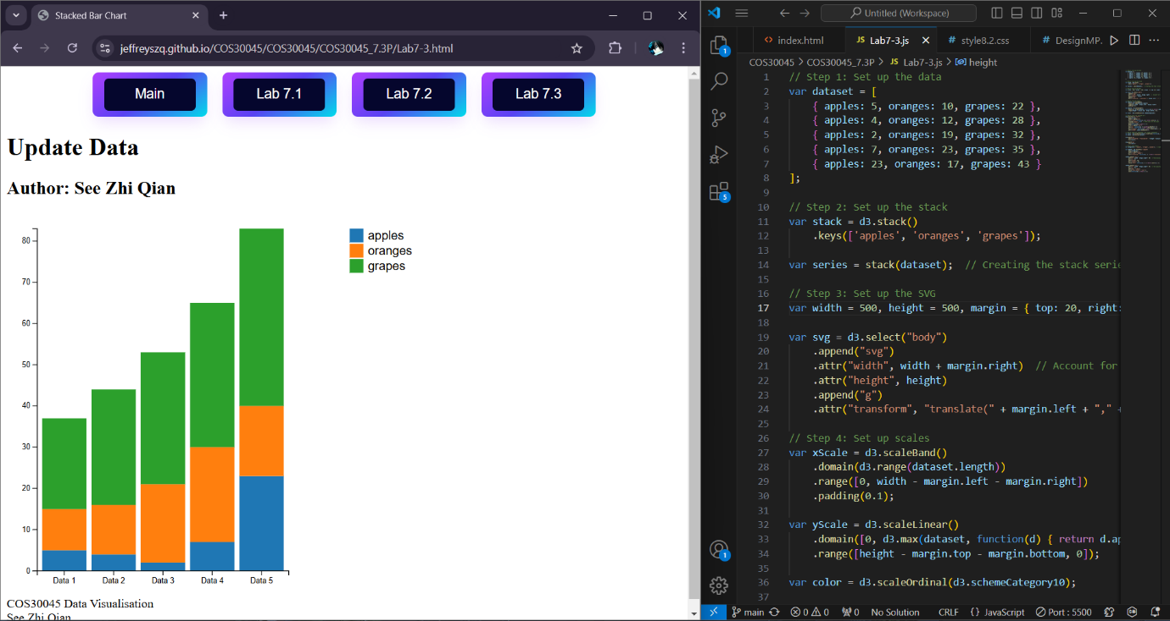
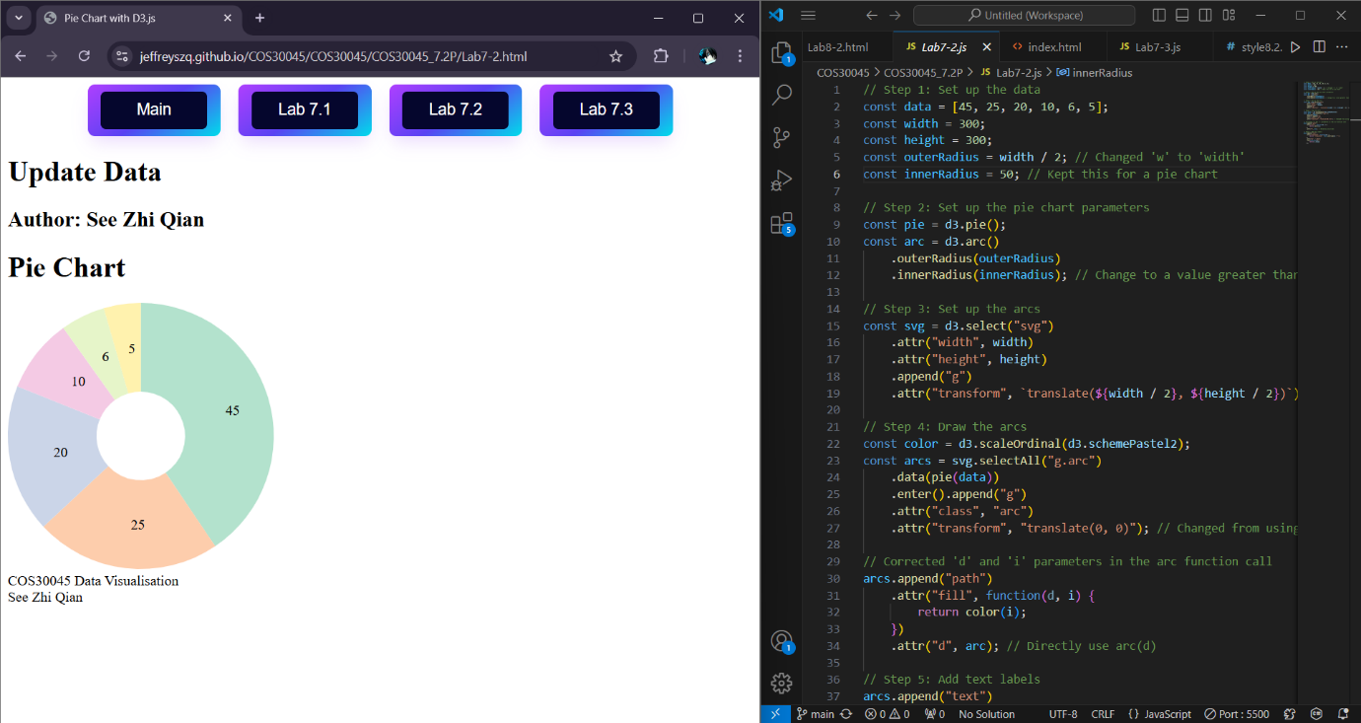
Lab 7.2
Lab7.3
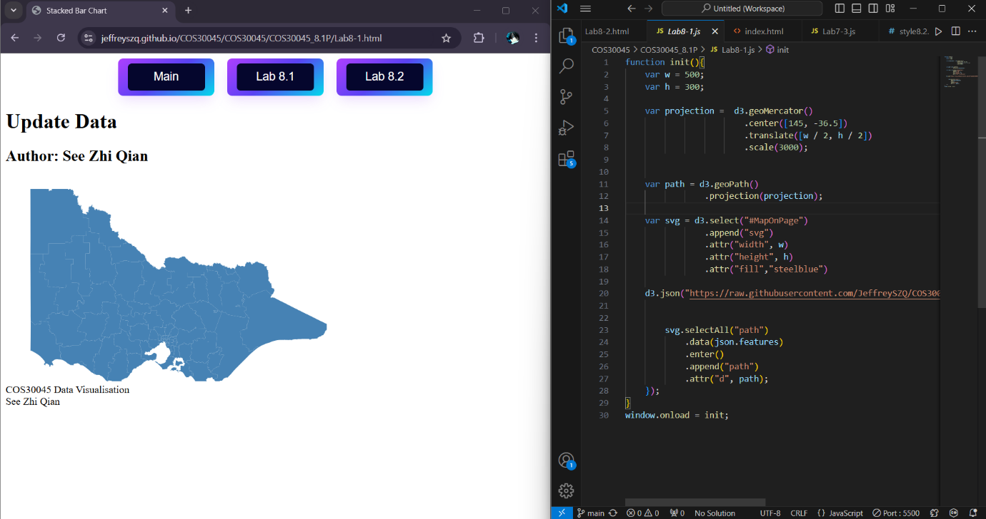
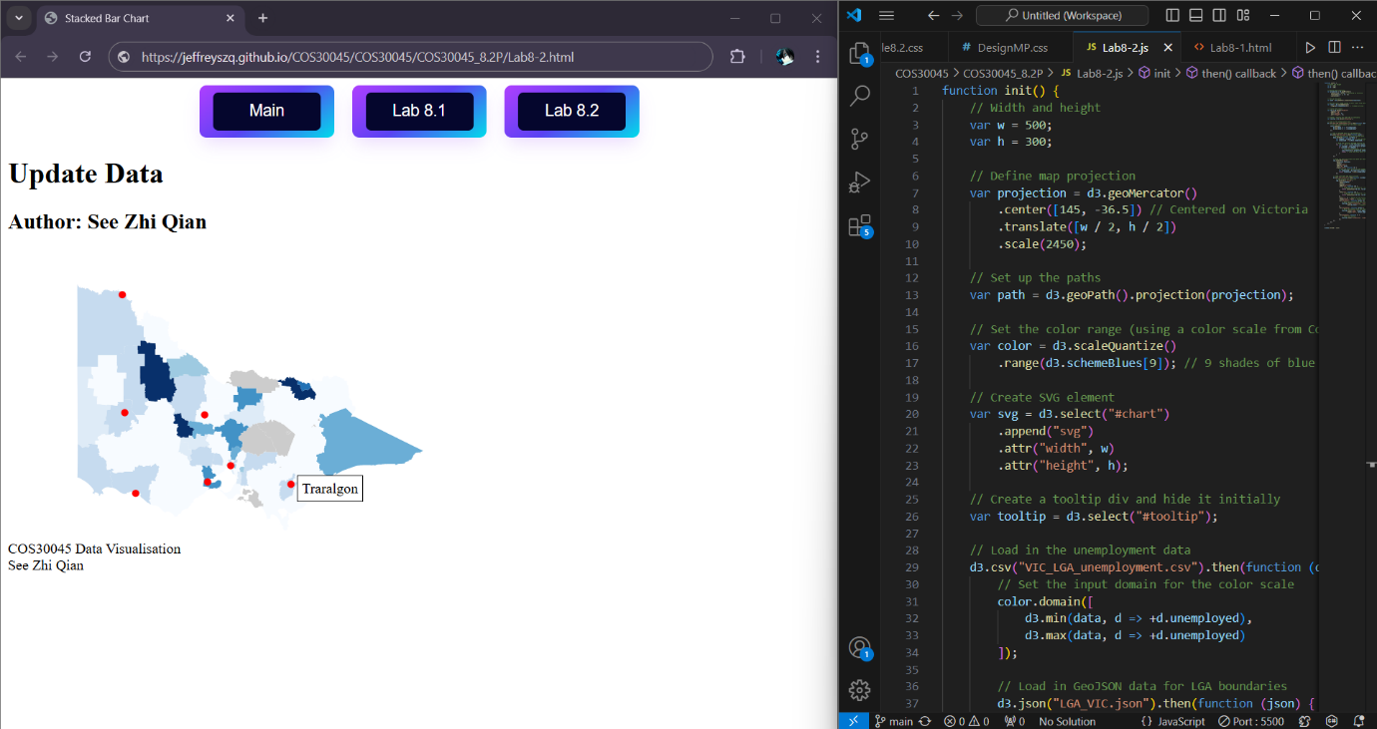
Lab8.1
Lab8.2

